**Report on plotter based on Qt**

**1. OVERVIEW**

The plotter is based on C++ for relatively faster execution that comes with the language, while keeping in consideration practical aspects like available open-source libraries. It uses Qt, a powerful C++ SDK that provides support for complicated GUI (and corresponding interactions) and has a wide community. For plotting, specifically, the QCustomPlot library was used.

**1.1 SCOPE AND FEATURES**

* The plotter supports plotting off a live datastream from a serial port, or a text file.
* 2 plotting modes are supported, with 1 plot per graph or 3 plots per graph. Gps data in NMEA format is plotted in google earth using a kml file as the interface.
* Multiple tabs are automatically created as per the number of streams of data from the input source.
* When using serial port as an input, a file with the exact recieved data is created and stored automatically, and can be directly plotted from later. This is to ensure that corrupted unparsable data which might be human-readable is preserved.
* Multiple files can be read from and plotted in one session, with the option of plotting live serial data parrallelly.
* Expected functionality such as scaling, scrolling, hiding axes and popping out tabs into a new window are implemented.

**2. USAGE**

**2.1 INPUT FORMAT**

The format used to input data is used to determine the number of plots per graph.

Input through both serial and files must have one of the following formats:

* For a graph with 3 plots, X, Y, and Z vs T,
  + [4 lowercase letter graph name]:X[X-value]Y[Y-value]Z[Z-value]T[Tvalue]
  + Example:
  + accl:X1Y2Z3T1
  + gyro:X4Y5Z6T1
* For a graph with 1 plot, W vs T
  + [4 lowercase letter graph name]:W[W-value]T[Tvalue]
  + Example:
  + baro:W1T1
  + sine:W0T1

In both cases, each line of input is expected to end in a newline (\n) character.

The value of T is expected to indicate time elapsed, and is thus the key axis, the other axes being value axes. Hence, T must have a steadily increasing value for every subsequent input in the same plot.

**2.2 UI**

**2.2.1 Main window**

**At launch:**

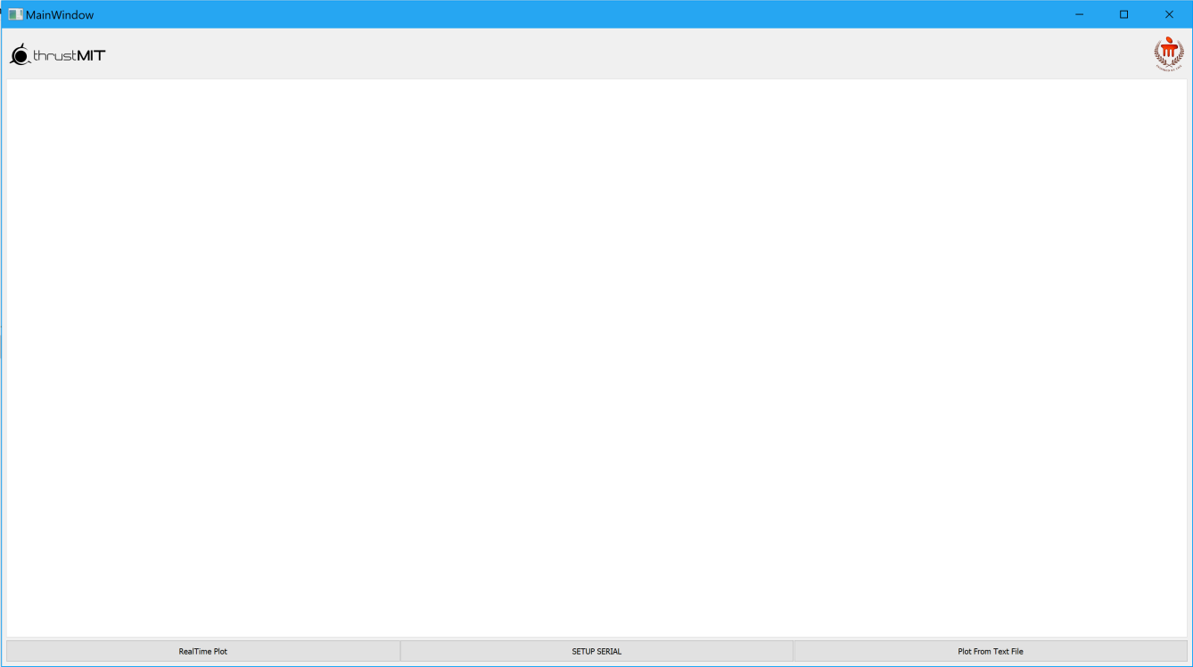

**With data**

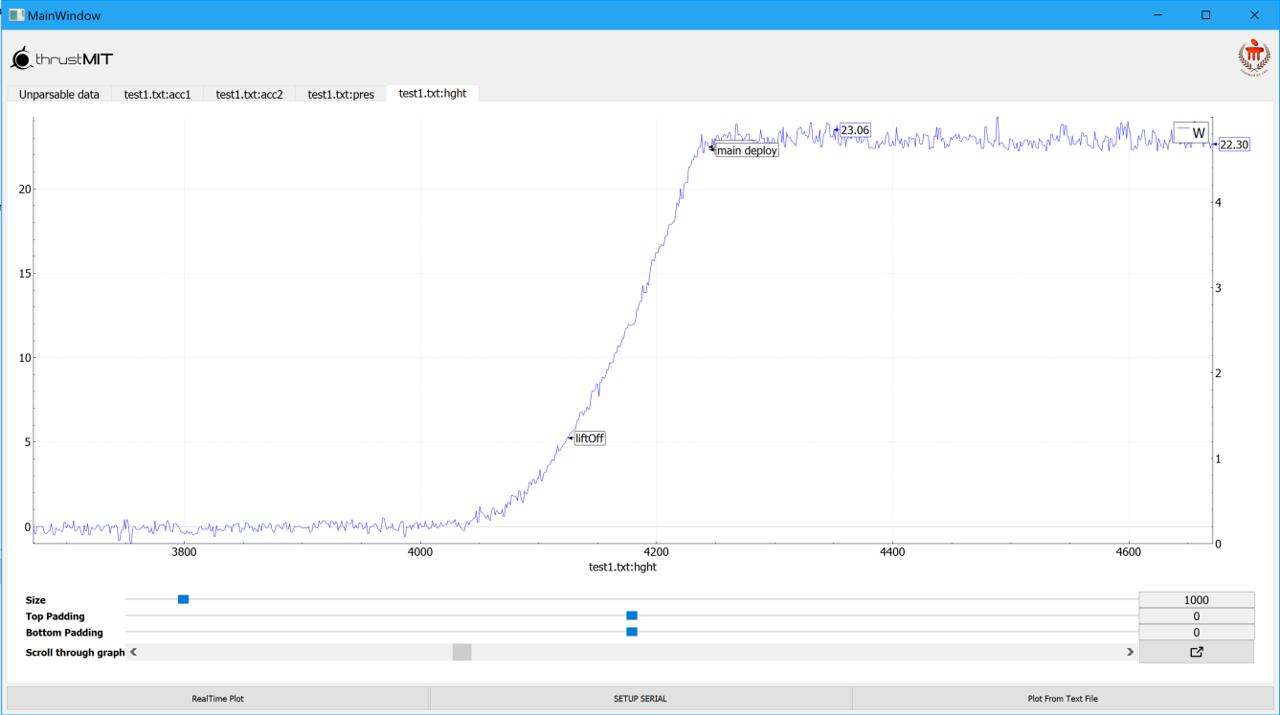

**RealTime Plot:** Starts reading the configured serial port and plotting any data it recognizes

**SETUP SERIAL:** Leads to Serial setup window. Used to plot via serial.

**Plot from text file:** Leads to file setup window. Used to select file to plot from.

**2.2.2 Serial setup**

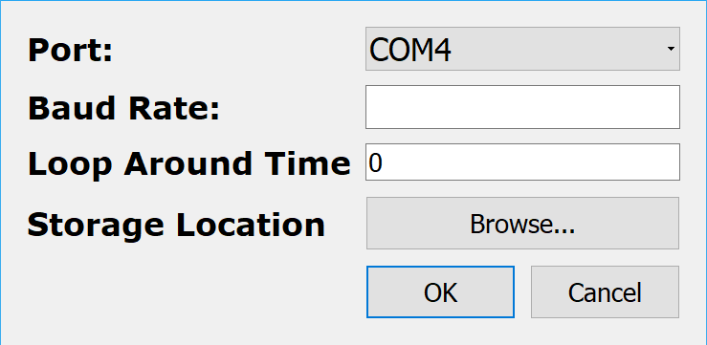

**Port:** Used to select source port for serial input. Available ports are populated into the ComboBox automatically.

**Baud Rate:** Enter the baud rate of the serial source here.

**Loop Around Time:** Enter max ‘T’ value of input after which subsequent points start from 0 time. This is to support 8-bit sources that will loop around to 0 after some time.

**Storage location:** Opens a dialog box used to select a folder. Inside, the selected folder, a new folder is created and named as the value of miliseconds elapsed since Epoch. Inside this folder files with recieved data are stored.

**Pressing OK without all fields configured will lead failiure of configuration.**

**Pressing OK will save the configuration to a file which will be read from when plotting is later started. This persists across restarts of the program.**

**Press Cancel to close Serial Setup window without saving configuration data.**

**2.2.4 Graphs**

**3 plots /graph**

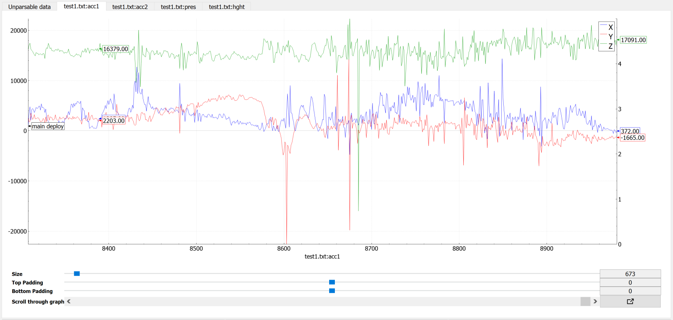

**1 plot /graph**

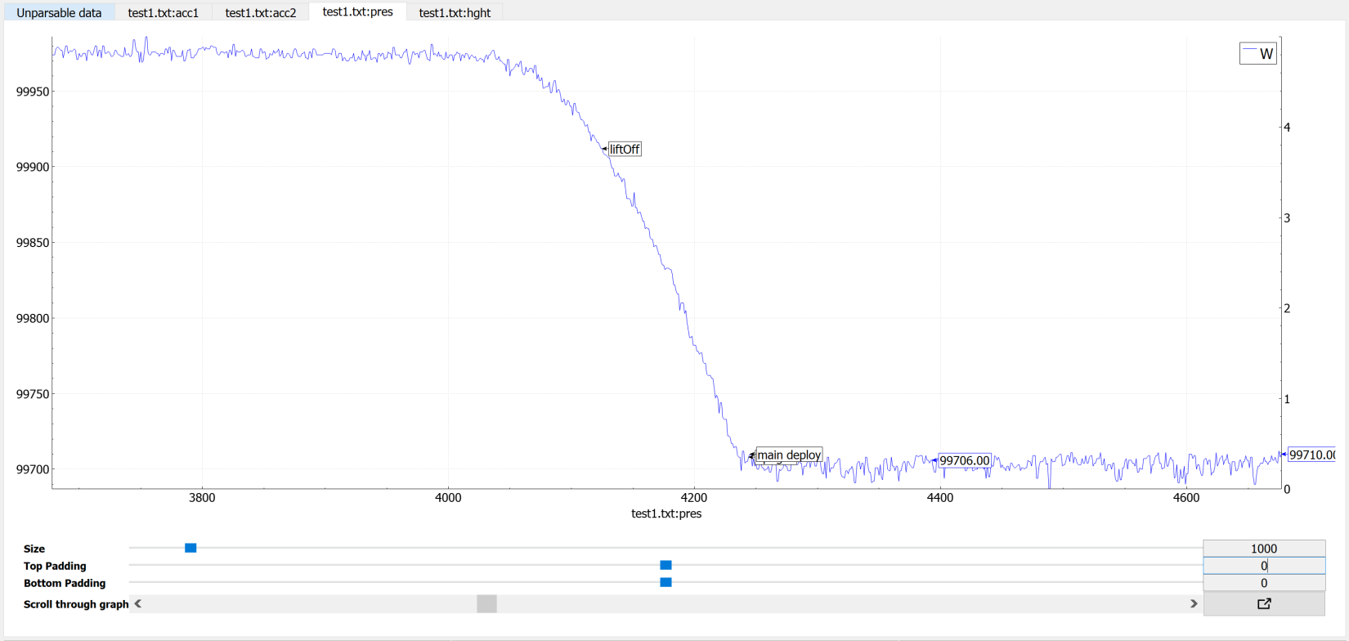

**UI ELEMENTS**

**Size:** Number of points on the graph at a time. Slider has a range of 50 to 1000, while the Textbox can be set to a custom value, Higher, lower or within the range of the slider.

**Top Padding:** Used to set padding above the graph. Slider has a range of -1000 to 1000, while the Textbox can be set to a custom value, Higher, lower or within the range of the slider, Including floating point values.

**Bottom Padding:** Used to set padding below the graph. Slider has a range of -1000 to 1000, while the Textbox can be set to a custom value, Higher, lower or within the range of the slider, Including floating point values.

**Scroll through graph:** Used to scroll through the graph if the entirety of it cannot be displayed at once. If plotting from serial, setting this to maximum will result in plotting the latest set of values, while by decreasing it enables viewing previous values from the current plotting session.

**Clear (Only visible when plotting from serial):** Used to clear all data in the graph. Only new data recieved from that point will be visible in the graph, but the file saving the data will retain previous data.

**PopIn/PopOut:** Initially in pop-out mode, pops out the tab containing the graph and create a seperate window for it. The button then changes to pop-in mode and has the opposite effect.

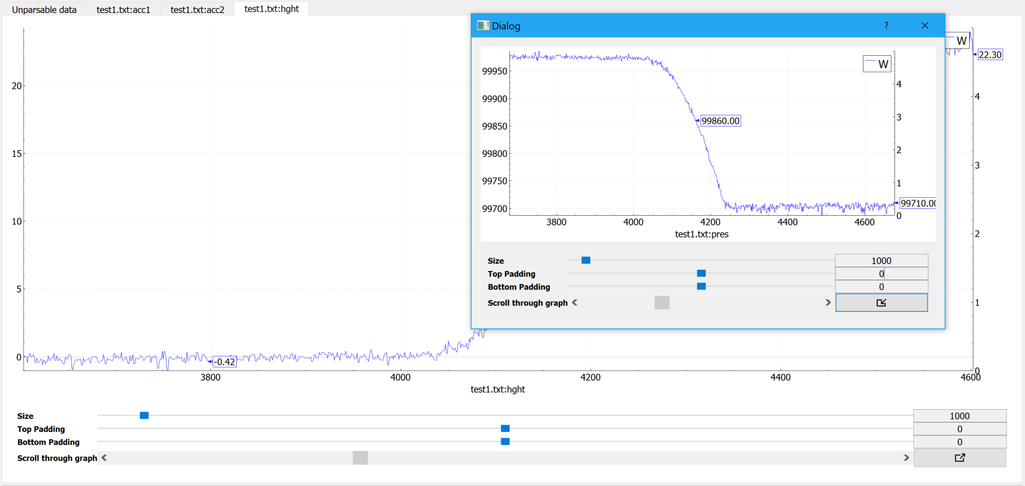

**INTERACTIVE ELEMENTS**

**Histogram:** Clicking on a specific axis on the graph’s histogram toggles the axis’ visibility.

**The graph:**  Hovering the mouse over any part of the plot will display the Y-axis values for the corresponding X-axis value of the point over which the mouse is hovering.

**PASSIVE FEATURES**

**Graph name** can be seen just below the X-axis, centered W.R.T. the screen.

**Auto scaling** of the axes is enabled, according to the data visible on the graph at the time. Padding provides offset to this scaling.